1. **Perform Affine Transformation on the image.**

**Aim:**

To perform affine transformation on the input image.  
  
**Code:**

import cv2

import numpy as np

img = cv2.imread("C:\\Users\\prith\\Documents\\CV\\cvimage.jpg")

rows, cols, _ = img.shape

pts1 = np.float32([[50, 50], [200, 50], [50, 200]])

pts2 = np.float32([[10, 100], [200, 50], [100, 250]])

M = cv2.getAffineTransform(pts1, pts2)

dst = cv2.warpAffine(img, M, (cols, rows))

cv2.imshow('Affine Transformation', dst)

cv2.waitKey(0)

cv2.destroyAllWindows()

**Input:**

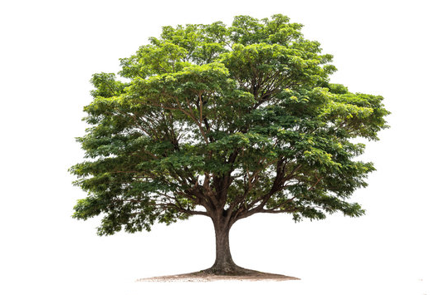

**Output:**

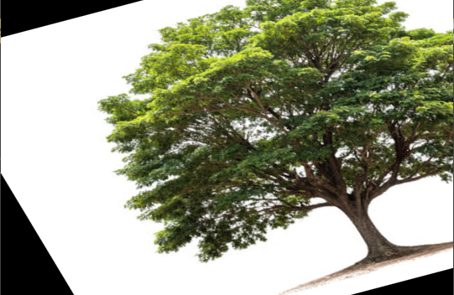

**Result:**

Python code to perform affine transformation on the input image has been executed successfully.